MCP System Architecture

This document outlines the technical architecture for the Multi-Agent Control Platform (MCP). It follows a modular design to ensure extensibility for new AI models and messaging platforms.

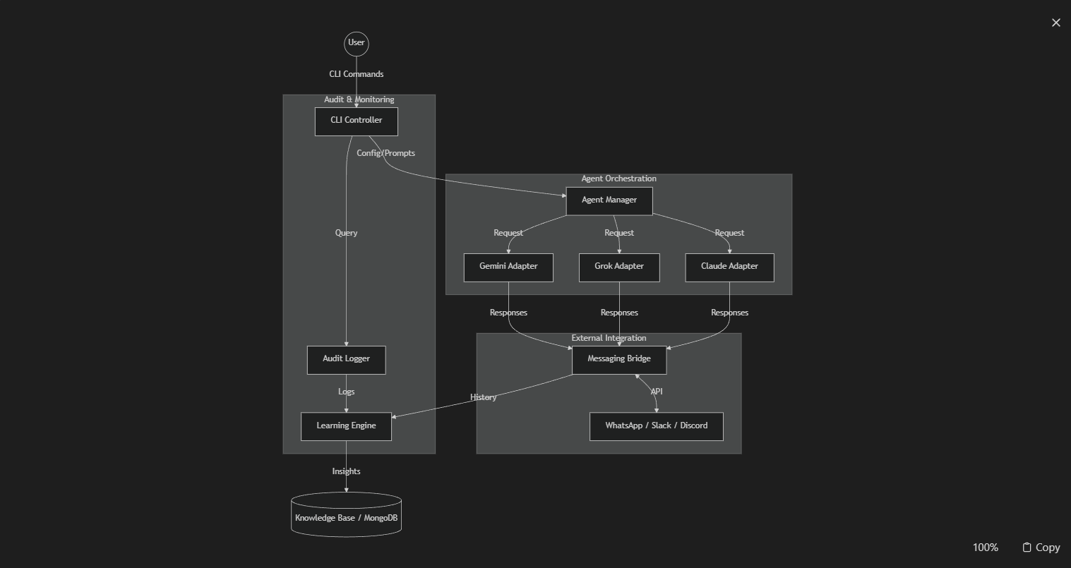
High-Level Data Flow

Component Breakdown
. CLI Layer (Python / Argparse)
- Responsibility: Interface for the human moderator.
- Functions: Configure agents, start/stop sessions, and query the audit trail.
2. Agent Manager (The Orchestrator)
- Registry: Maintains a list of active AI adapters and their credentials.
- Moderator: Implements the logic (Round-Robin, Weighted, etc.) to determine which AI speaks next.
- Context Management: Ensures that despite different APIs, all agents receive a consistent conversation history.
3. Messaging Bridge (The Connector)
- Normalize: Converts diverse API outputs into a standard message format.
- Transport: Handles the specific API calls to Twilio (WhatsApp) or other webhooks.
4. Learning Engine (The "Librarian")
- Analysis: Uses a specialized "Learning Model" to scan the conversation for consensus or conflict.
- Persistence: Writes structured data (JSON/MongoDB) that can be queried later by the agents or the user.
5. Audit Layer
- Transparency: Every single token sent and received is timestamped and signed with the AgentID for compliance and debugging.
Technology Stack (Proposed)
- Core: Python 3.11+
- AI SDKs: google-generativeai, anthropic, openai (for Grok/GPT)
- MCP Framework: mcp (Model Context Protocol) Python SDK
- Database: MongoDB (Insights) & SQLite (Logs)
- CLI: prompt-toolkit

